# 20210715
[s.belogrud@nb2339]# ssh bsv@vm-puppetmaster02p.tcsbank.ru
Last login: Wed Apr 21 15:01:48 2021 from 172.30.71.28
[bsv@vm-puppetmaster02p ~]$ sudo -i
[sudo] password for bsv:
[root@vm-puppetmaster02p ~]#

[root@vm-puppetmaster02p ~]# for var1 in vm-uwp-build02 vm-uwp-build03 vm-uwp-build04 vm-uwp-build05 vm-uwp-build06 vm-uwp-build07 vm-uwp-build08 vm-uwp-build09 vm-uwp-build10 ; do puppet node clean ${var1}.tcsbank.ru ; done

[root@ds-pr-acq-clearing-gw01p ~]# rm -rf /etc/puppetlabs/puppet/ssl/
[root@ds-pr-acq-clearing-gw01p ~]# puppet agent -t --test
[root@ds-pr-acq-clearing-gw01p ~]# puppet agent -t --debug
[root@ds-pr-acq-clearing-gw01p ~]# puppet --version

#
# 20200924
#
[s.belogrud@TCS4357]# pwd
/home/mobaxterm/work/puppet/control
[s.belogrud@TCS4357]

[s.belogrud@TCS4357]# git branch
* production
[s.belogrud@TCS4357]#

[s.belogrud@TCS4357]# git pull
stty: standard input: Inappropriate ioctl for device
remote: Enumerating objects: 820, done.
remote: Counting objects: 100% (820/820), done.
remote: Compressing objects: 100% (378/378), done.
Получение объектов: remote: Total 820 (delta 427), reused 804 (delta 422), pack-reused 0
Получение объектов: 100% (820/820), 166.99 KiB | 197.00 KiB/s, готово.
Определение изменений: 100% (427/427), завершено с 21 локальным объектом.
Из vm-gitlab01.tcsbank.ru:Puppet/control
2c31a574..ad6fa9cd production -> origin/production
* [новая ветка] SD4420999 -> origin/SD4420999
Обновление 2c31a574..ad6fa9cd
Fast-forward
manifests/00_site.pp | 33 +++++++++++++++++++++++++++++++++
site/profile/manifests/accounts/a_edomskiy.pp | 27 +++++++++++++++++++++++++++
site/profile/manifests/accounts/a_i_novichkova.pp | 13 ++++++-------
…
77 files changed, 889 insertions(+), 174 deletions(-)
...
create mode 100644 site/role/manifests/sso_prod_rancher_node.pp
create mode 100644 site/role/manifests/tma_mongo.pp
[s.belogrud@TCS4357]#

[s.belogrud@TCS4357]# git checkout -b 20200924_JIRA_IN_420
Переключено на новую ветку «20200924_JIRA_IN_420»
[s.belogrud@TCS4357]#

[s.belogrud@TCS4357]# git commit --author='Sergey Belogrud <s.belogrud@tinkoff.ru>' -m "JIRA#IN-420. Were added several new host to create there users." manifests/00_site.pp
[20200924_JIRA_IN_420 3913ad82] JIRA#IN-420. Were added several new host to create there users.
1 file changed, 1 insertion(+), 1 deletion(-)
[s.belogrud@TCS4357]#

[s.belogrud@TCS4357]# git branch
* 20200924_JIRA_IN_420
production
[s.belogrud@TCS4357]# git push origin 20200924_JIRA_IN_420
stty: standard input: Inappropriate ioctl for device
Enumerating objects: 7, готово.
Подсчет объектов: 100% (7/7), готово.
Delta compression using up to 8 threads
Сжатие объектов: 100% (4/4), готово.
Запись объектов: 100% (4/4), 436 bytes | 22.00 KiB/s, готово.
Total 4 (delta 3), reused 0 (delta 0)
remote:
remote: *** Checking puppet code style ***
remote:
remote: *** Checking puppet manifest syntax ***
remote:
remote: *** Checking puppet template(epp) syntax ***
remote:
remote: *** Checking ruby template(erb) syntax ***
remote:
remote: *** Checking ruby syntax ***
remote:
remote: *** Checking YAML syntax ***
remote:
remote: To create a merge request for 20200924_JIRA_IN_420, visit:
remote: https://vm-gitlab01.tcsbank.ru/Puppet/control/merge_requests/new?merge_request%5Bsource_branch%5D=20200924_JIRA_IN_420
remote:
To vm-gitlab01.tcsbank.ru:Puppet/control.git
* [new branch] 20200924_JIRA_IN_420 -> 20200924_JIRA_IN_420
[s.belogrud@TCS4357]#

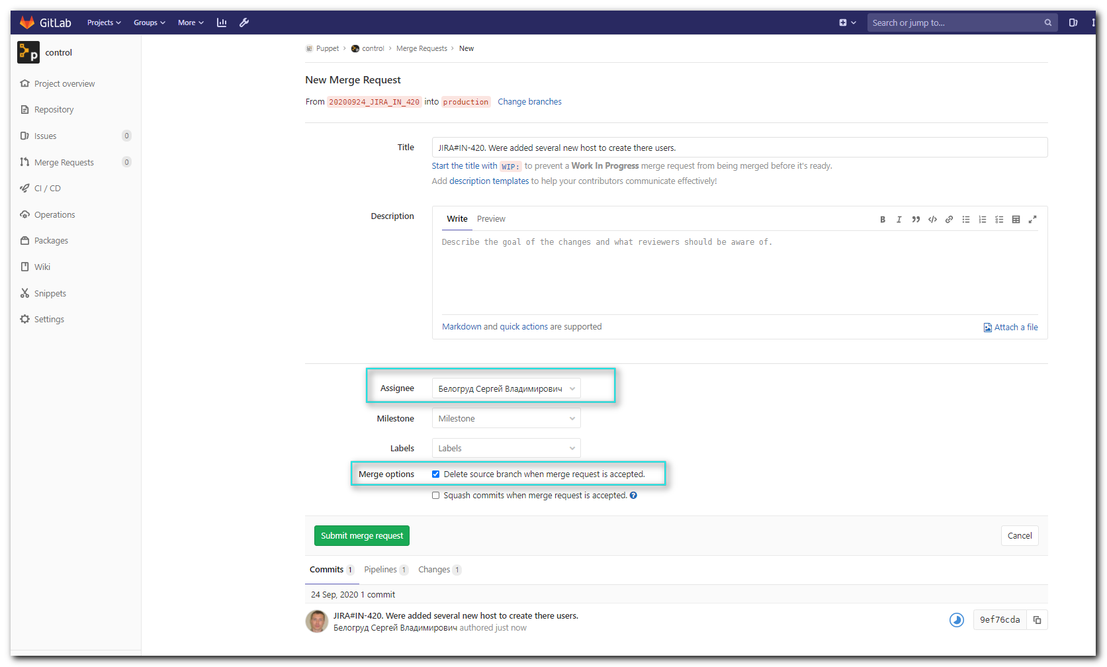
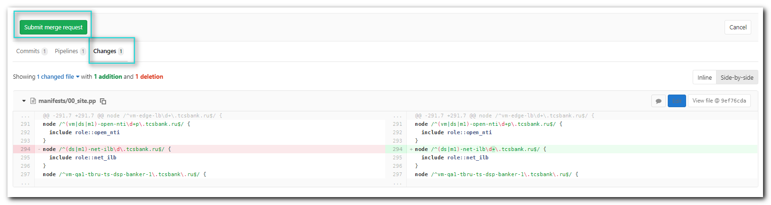
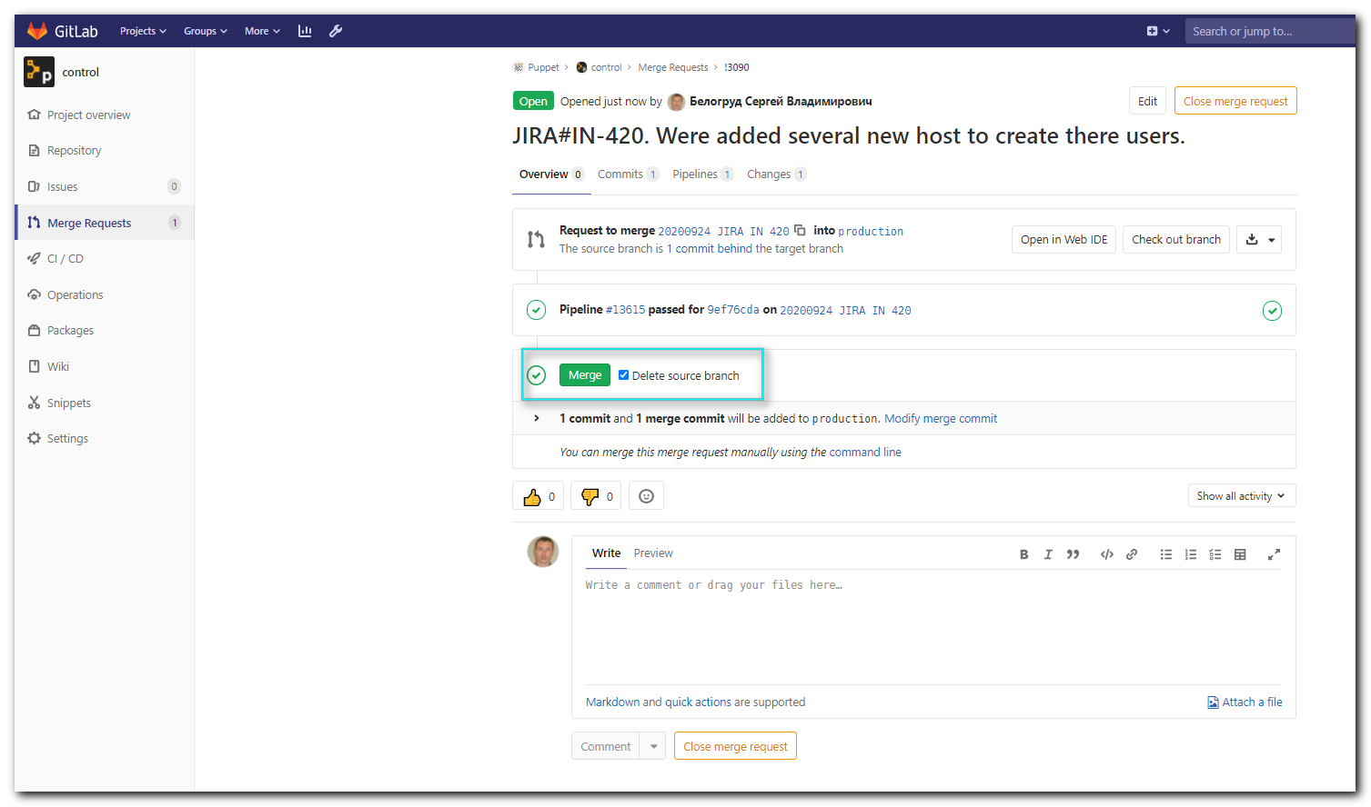
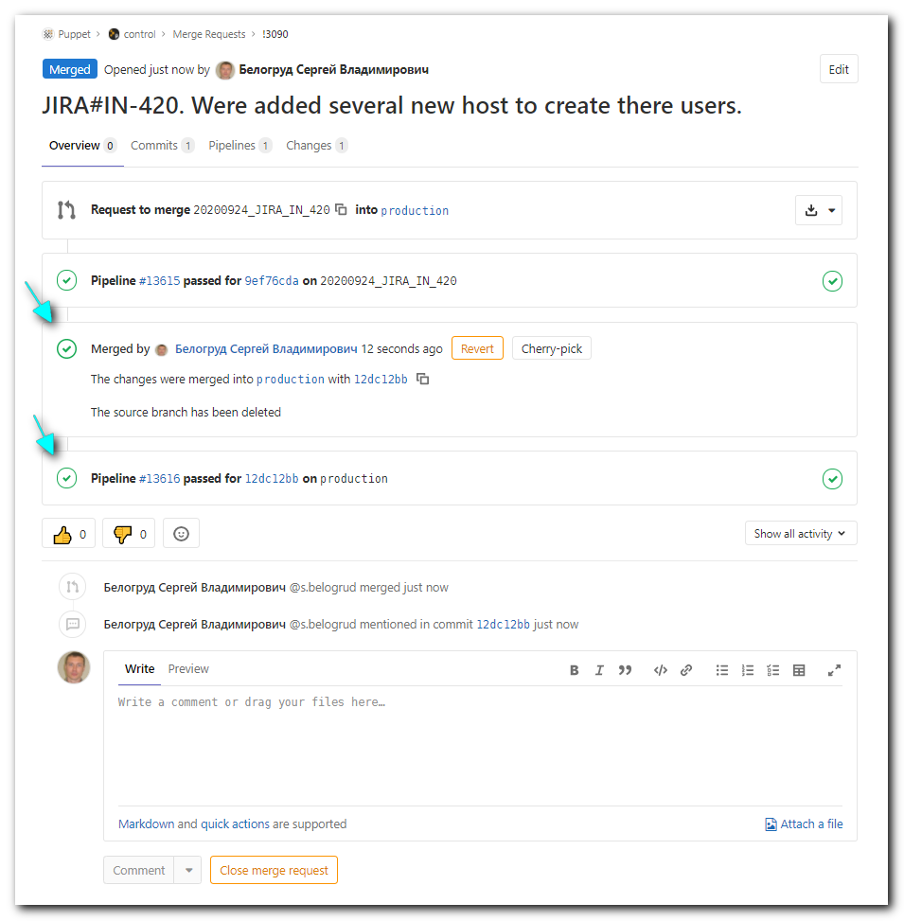

[s.belogrud@TCS4357]# egrep -irle "sakalkin" site/profile/manifests/accounts/ #grep_accounts
site/profile/manifests/accounts/net_admins.pp
site/profile/manifests/accounts/vvs.pp
[s.belogrud@TCS4357]#

[s.belogrud@TCS4357]# egrep -re "ilb" site/role/manifests/ #grep_role
site/role/manifests/net_ilb.pp:class role::net_ilb {
site/role/manifests/net_qilb.pp:class role::net_qilb {
[s.belogrud@TCS4357]#

[s.belogrud@TCS4357]# egrep -A 1 -B 1 -ire "ilb" manifests/ #grep_site
manifests/00_site.pp-}
manifests/00_site.pp:node /^(ds|m1)-net-ilb0\d\.tcsbank.ru$/ {
manifests/00_site.pp: include role::net_ilb
manifests/00_site.pp-}
--
manifests/00_site.pp-node /^(ds|m1)-net-qlb\d+\.tcsbank.ru$/ {
manifests/00_site.pp: include role::net_ilb
manifests/00_site.pp-}
manifests/00_site.pp:node /^(ds|m1)-net-qilb\d+\.tcsbank.ru$/ {
manifests/00_site.pp: include role::net_qilb
manifests/00_site.pp-}
--
manifests/00_site.pp-node /^(ds|m1)-net-dmz-l7-lb\d+\.tcsbank\.ru$/ {
manifests/00_site.pp: include role::net_ilb
manifests/00_site.pp-}
[s.belogrud@TCS4357]#

#
# Here is a documentation about moudules of puppet:
https://puppet.com/docs/puppet/5.5/types/user.html

#
# 20181026
#
[s.belogrud@TCS4357]# egrep -irle "ananyev|baranov|lobachev" site/profile/manifests/accounts/ #grep_accounts
site/profile/manifests/accounts/a_lobachev.pp
site/profile/manifests/accounts/a_lobachev_wo_sudo.pp
site/profile/manifests/accounts/e_ananyev.pp
site/profile/manifests/accounts/isbaranov.pp
site/profile/manifests/accounts/isbaranov_sudo.pp

[s.belogrud@TCS4357]# egrep -ire "infra" manifests/ #grep_site
manifests/00_site.pp:node /^vm-infra-tbru-ts-logs-\d+\.tcsbank\.ru$/ {
manifests/00_site.pp:node /^(ds|m1)-pr-infra-lb01\.tcsbank\.ru$/ {
manifests/00_site.pp: include role::pr_infra
manifests/01_mvno.pp:node /^(m1|ds)-mvno-dns-infra01\.tcsbank\.ru$/ {
[s.belogrud@TCS4357]#

[s.belogrud@TCS4357]# grep -irle "pr_infra" site/role/manifests/ #grep_role
site/role/manifests/pr_infra.pp
[s.belogrud@TCS4357]#

!!!!!!!!
#
puppetserver: vm-puppetmaster02p.tcsbank.ru

root@vm-tinkofflabs01:~# telnet vm-puppetmaster02p.tcsbank.ru 8140
Trying 10.216.40.228...

root@vm-tinkofflabs01:~#

# Get puppet server name
root@vm-blockchain-s7:~# grep -ire "^server" /etc/puppet*/**/puppet.conf
server = vm-puppetmaster02p.tcsbank.ru
root@vm-blockchain-s7:~#

[root@vm-mcafee-wr01 ~]# puppet config print server
puppet
[root@vm-mcafee-wr01 ~]#

# Get all config information
[root@vm-mcafee-wr01 ~]# puppet config print all

[root@vm-activemq-app02 ~]# cat $(puppet agent --configprint classfile)

[root@ds-postgresql118p ~]# puppet agent -t
Error: Could not request certificate: The certificate retrieved from the master does not match the agent's private key. Did you forget to run as root?
Certificate fingerprint: 32:48:97:88:0C:3E:16:00:EF:8C:DE:38:F1:5E:CB:5D:C0:77:E2:C0:F9:13:CB:37:B5:3A:77:24:C4:BC:A3:16
To fix this, remove the certificate from both the master and the agent and then start a puppet run, which will automatically regenerate a certificate.
On the master:
puppet cert clean ds-postgresql118p.tcsbank.ru
On the agent:
1a. On most platforms: find /etc/puppetlabs/puppet/ssl -name ds-postgresql118p.tcsbank.ru.pem -delete
1b. On Windows: del "\etc\puppetlabs\puppet\ssl\certs\ds-postgresql118p.tcsbank.ru.pem" /f
2. puppet agent -t

Exiting; failed to retrieve certificate and waitforcert is disabled
[root@ds-postgresql118p ~]#

#
# 20180809
#
Check out, review, and merge locally

Step 1. Fetch and check out the branch for this merge request
git fetch origin
git checkout -b 20180809_SD1609884 origin/20180809_SD1609884

Step 2. Review the changes locally

Step 3. Merge the branch and fix any conflicts that come up
git checkout production
git merge --no-ff 20180809_SD1609884

Step 4. Push the result of the merge to GitLab
git push origin production

Tip: You can also checkout merge requests locally by following these guidelines (https://vm-gitlab01.tcsbank.ru/help/user/project/merge_requests/index.md#checkout-merge-requests-locally).

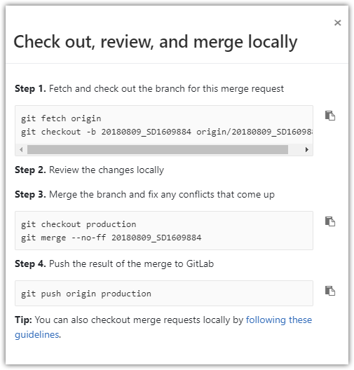

#
# 20180718
# Below are places were key file and directories are.
#
[s.belogrud@TCS4357]# grep -irle "ivanov" site/profile/manifests/accounts/ #grep_accounts
[s.belogrud@TCS4357]# vim -o site/role/manifests/dmz_wallarm.pp site/profile/manifests/accounts/max.pp manifests/00_site.pp
[s.belogrud@TCS4357]# git commit --author='Sergey Belogrud <s.belogrud@tinkoff.ru>' -m "SD#1547474. “ path_and_file_name

#
# Wrong and right way to create users on server.
#
[s.belogrud@TCS4357]# find site/profile/manifests/accounts/ -type f | egrep -ie "maslov|kocher|kataev|ivanov|lapaev|fedorov|saraev" | xargs grep -e "accounts"
site/profile/manifests/accounts/a_a_fedorov.pp:class profile::accounts::a_a_fedorov {
site/profile/manifests/accounts/a_ivanov45.pp:class profile::accounts::a_ivanov45 {
site/profile/manifests/accounts/a_lapaev.pp:class profile::accounts::a_lapaev {
site/profile/manifests/accounts/d_a_saraev.pp:class profile::accounts::d_a_saraev {
site/profile/manifests/accounts/d_maslovskaya.pp:class profile::accounts::d_maslovskaya inherits profile::accounts::params {
site/profile/manifests/accounts/i_kochergin.pp:class profile::accounts::i_kochergin inherits profile::accounts::params {
site/profile/manifests/accounts/v_kataev.pp:class profile::accounts::v_kataev inherits profile::accounts::params {
[s.belogrud@TCS4357]#

[s.belogrud@TCS4357]# git branch 20180618_SD1372232
[s.belogrud@TCS4357]# git checkout 20180618_SD1372232
Switched to branch '20180618_SD1372232'
# Or use one command.
[s.belogrud@TCS4357]# git checkout -b 20180711_SD1520198
Switched to a new branch '20180711_SD1520198'
[s.belogrud@TCS4357]#

#
# I see profile::base, so I use it too.
# It’s just a file, where I’ve found same users.
[s.belogrud@TCS4357]# cat ./site/role/manifests/qa_kafka.pp
class role::qa_kafka {
include profile::base
include profile::accounts::i_kochergin
include profile::accounts::d_maslovskaya
include profile::accounts::v_kataev
include profile::accounts::a_ivanov45
include profile::accounts::a_lapaev
}
[s.belogrud@TCS4357]#

[s.belogrud@TCS4357]# vim manifests/00_site.pp

[s.belogrud@TCS4357]# tail -n 12 manifests/00_site.pp
}
node /^vm-qa1-tbru-ts-dsp-banker-1\.tcsbank\.ru$/ {
include profile::base
include profile::accounts::i_kochergin
include profile::accounts::d_maslovskaya
include profile::accounts::v_kataev
include profile::accounts::a_ivanov45
include profile::accounts::a_lapaev
include profile::accounts::a_a_fedorov
include profile::accounts::d_a_saraev
}

[s.belogrud@TCS4357]#

#
# I did follow without commit and came a cross with follow errors...
[s.belogrud@TCS4357]# git branch
* 20180618_SD1372232
production
[s.belogrud@TCS4357]# git push origin 20180618_SD1372232
Total 0 (delta 0), reused 0 (delta 0)
remote: fatal: This operation must be run in a work tree
remote:
remote: *** Checking puppet code style ***
remote:
remote: *** Checking puppet manifest syntax ***
remote:
remote: *** Checking puppet template(epp) syntax ***
remote:
remote: *** Checking ruby template(erb) syntax ***
remote:
remote: *** Checking ruby syntax ***
remote:
remote: *** Checking YAML syntax ***
remote:
remote: To create a merge request for 20180618_SD1372232, visit:
remote: https://vm-gitlab01.tcsbank.ru/Puppet/control/merge_requests/new?merge_request%5Bsource_branch%5D=20180618_SD1372232
remote:
To git@vm-gitlab01.tcsbank.ru:Puppet/control.git
* [new branch] 20180618_SD1372232 -> 20180618_SD1372232
[s.belogrud@TCS4357]#

#
# Something useful was removed...
root@vm-qa1-tbru-ts-dsp-banker-1:~# puppet agent -t --environment 20180618_SD1372232
Info: Using configured environment '20180618_SD1372232'
Info: Retrieving pluginfacts
Info: Retrieving plugin
Notice: /File[/opt/puppetlabs/puppet/cache/lib/facter/archive_windir.rb]/ensure: removed
Notice: /File[/opt/puppetlabs/puppet/cache/lib/facter/env_temp_variable.rb]/ensure: removed
Notice: /File[/opt/puppetlabs/puppet/cache/lib/facter/gcs_puppet.rb]/ensure: removed
Notice: /File[/opt/puppetlabs/puppet/cache/lib/facter/java_deployment.rb]/ensure: removed
Notice: /File[/opt/puppetlabs/puppet/cache/lib/facter/jenkins.rb]/ensure: removed
Notice: /File[/opt/puppetlabs/puppet/cache/lib/facter/mco_config.rb]/ensure: removed
...
Notice: /File[/opt/puppetlabs/puppet/cache/lib/puppet_x/jenkins.rb]/ensure: removed
Info: Loading facts
Error: Could not retrieve catalog from remote server: Error 500 on SERVER: Server Error: Evaluation Error: Error while evaluating a Function Call, Could not find class ::tcs_nrpe for vm-qa1-tbru-ts-dsp-banker
-1.tcsbank.ru at /etc/puppetlabs/code/environments/20180618_SD1372232/site/profile/manifests/base/nrpe.pp:2:3 on node vm-qa1-tbru-ts-dsp-banker-1.tcsbank.ru
Warning: Not using cache on failed catalog
Error: Could not retrieve catalog; skipping run
root@vm-qa1-tbru-ts-dsp-banker-1:~#

# Here it’s a mistake - there was not commit made.
[s.belogrud@TCS4357]# git status
On branch 20180618_SD1372232
Changes not staged for commit:
(use "git add <file>..." to update what will be committed)
(use "git checkout -- <file>..." to discard changes in working directory)

modified: manifests/00_site.pp

no changes added to commit (use "git add" and/or "git commit -a")
[s.belogrud@TCS4357]#

#
# Need commit.
[s.belogrud@TCS4357]# git commit --author='Sergey Belogrud <s.belogrud@tinkoff.ru>' -m "SD#1372232. Were created users on server." manifests/00_site.pp
[20180618_SD1372232 f53cd6b] SD#1372232. Were created users on server.
Author: Sergey Belogrud <s.belogrud@tinkoff.ru>
1 file changed, 11 insertions(+)
[s.belogrud@TCS4357]#

[s.belogrud@TCS4357]# git push origin 20180618_SD1372232
Counting objects: 4, done.
Delta compression using up to 8 threads.
Compressing objects: 100% (4/4), done.
Writing objects: 100% (4/4), 531 bytes | 0 bytes/s, done.
Total 4 (delta 3), reused 0 (delta 0)
remote:
remote: *** Checking puppet code style ***
remote:
remote: *** Checking puppet manifest syntax ***
remote:
remote: *** Checking puppet template(epp) syntax ***
remote:
remote: *** Checking ruby template(erb) syntax ***
remote:
remote: *** Checking ruby syntax ***
remote:
remote: *** Checking YAML syntax ***
remote:
remote: To create a merge request for 20180618_SD1372232, visit:
remote: https://vm-gitlab01.tcsbank.ru/Puppet/control/merge_requests/new?merge_request%5Bsource_branch%5D=20180618_SD1372232
remote:
To git@vm-gitlab01.tcsbank.ru:Puppet/control.git
3c6f5df..f53cd6b 20180618_SD1372232 -> 20180618_SD1372232
[s.belogrud@TCS4357]#

#
# After commit everything became good.
#
root@vm-qa1-tbru-ts-dsp-banker-1:~# puppet agent -t --environment 20180618_SD1372232
Info: Using configured environment '20180618_SD1372232'
Info: Retrieving pluginfacts
Info: Retrieving plugin
Notice: /File[/opt/puppetlabs/puppet/cache/lib/facter/archive_windir.rb]/ensure: defined content as '{md5}a646f8234e87041223c97dd919801ad8'
Notice: /File[/opt/puppetlabs/puppet/cache/lib/facter/env_temp_variable.rb]/ensure: defined content as '{md5}c13f4c4e5f61d5bf559760f5010c747e'
....
Notice: /File[/opt/puppetlabs/puppet/cache/lib/puppet_x/jenkins/type]/ensure: created
Notice: /File[/opt/puppetlabs/puppet/cache/lib/puppet_x/jenkins/type.rb]/ensure: defined content as '{md5}45910dd8ebd8fc622243e46f9158181c'
Notice: /File[/opt/puppetlabs/puppet/cache/lib/puppet_x/jenkins/type/cli.rb]/ensure: defined content as '{md5}0dc5183e9f5714b3bb0bb6f8299cd994'
Notice: /File[/opt/puppetlabs/puppet/cache/lib/puppet_x/jenkins/util.rb]/ensure: defined content as '{md5}7de344fbd30dd09d3533184c0447e89e'
Info: Loading facts
Info: Caching catalog for vm-qa1-tbru-ts-dsp-banker-1.tcsbank.ru
Info: Applying configuration version 'vm-puppetmaster02p.tcsbank.ru-20180618_SD1372232-f53cd6b5211'
Notice: /Stage[main]/Profile::Accounts::I_kochergin/Group[i.kochergin]/ensure: created
Notice: /Stage[main]/Profile::Accounts::I_kochergin/User[i.kochergin]/ensure: created
Notice: /Stage[main]/Profile::Accounts::D_maslovskaya/Group[d.maslovskaya]/ensure: created
Notice: /Stage[main]/Profile::Accounts::D_maslovskaya/User[d.maslovskaya]/ensure: created
Notice: /Stage[main]/Profile::Accounts::V_kataev/Group[v.kataev]/ensure: created
Notice: /Stage[main]/Profile::Accounts::V_kataev/User[v.kataev]/ensure: created
Notice: /Stage[main]/Profile::Accounts::A_ivanov45/Group[a.ivanov45]/ensure: created
Notice: /Stage[main]/Profile::Accounts::A_ivanov45/User[a.ivanov45]/ensure: created
Notice: /Stage[main]/Profile::Accounts::A_lapaev/Group[a.lapaev]/ensure: created
Notice: /Stage[main]/Profile::Accounts::A_lapaev/User[a.lapaev]/ensure: created
Notice: /Stage[main]/Profile::Accounts::A_lapaev/Ssh_authorized_key[a.lapaev@macmini-alapaev.local]/ensure: created
Notice: /Stage[main]/Profile::Accounts::A_a_fedorov/Group[a.a.fedorov]/ensure: created
Notice: /Stage[main]/Profile::Accounts::A_a_fedorov/User[a.a.fedorov]/ensure: created
Notice: /Stage[main]/Profile::Accounts::D_a_saraev/Group[d.a.saraev]/ensure: created
Notice: /Stage[main]/Profile::Accounts::D_a_saraev/User[d.a.saraev]/ensure: created
Notice: Applied catalog in 1.15 seconds
root@vm-qa1-tbru-ts-dsp-banker-1:~#

[s.belogrud@TCS4357]# vim -o manifests/00_site.pp site/role/manifests/banker.pp site/role/manifests/qa_kafka.pp
3 files to edit
[s.belogrud@TCS4357]#

[s.belogrud@TCS4357]# tail -n 4 manifests/00_site.pp
}
node /^vm-qa1-tbru-ts-dsp-banker-1\.tcsbank\.ru$/ {
include role::banker
}
[s.belogrud@TCS4357]# cat site/role/manifests/banker.pp
class role::banker {
include profile::base
include profile::accounts::i_kochergin
include profile::accounts::d_maslovskaya
include profile::accounts::v_kataev
include profile::accounts::a_ivanov45
include profile::accounts::a_lapaev
include profile::accounts::a_a_fedorov
include profile::accounts::d_a_saraev
}
[s.belogrud@TCS4357]#

#
# Right way - to create file with role.
#
[s.belogrud@TCS4357]# git add site/role/manifests/banker.pp
[s.belogrud@TCS4357]# git commit --author='Sergey Belogrud <s.belogrud@tinkoff.ru>' -m "SD#1372232. Were created users on server." manifests/00_site.pp site/role/manifests/banker.pp
[20180618_SD1372232 4c9c19d] SD#1372232. Were created users on server.
Author: Sergey Belogrud <s.belogrud@tinkoff.ru>
2 files changed, 11 insertions(+), 9 deletions(-)
create mode 100644 site/role/manifests/banker.pp
[s.belogrud@TCS4357]#

[s.belogrud@TCS4357]# git push origin 20180618_SD1372232
Counting objects: 8, done.
Delta compression using up to 8 threads.
Compressing objects: 100% (7/7), done.
Writing objects: 100% (8/8), 750 bytes | 0 bytes/s, done.
Total 8 (delta 5), reused 0 (delta 0)
remote:
remote: *** Checking puppet code style ***
remote:
remote: *** Checking puppet manifest syntax ***
remote:
remote: *** Checking puppet template(epp) syntax ***
remote:
remote: *** Checking ruby template(erb) syntax ***
remote:
remote: *** Checking ruby syntax ***
remote:
remote: *** Checking YAML syntax ***
remote:
remote: View merge request for 20180618_SD1372232:
remote: https://vm-gitlab01.tcsbank.ru/Puppet/control/merge_requests/661
remote:
To git@vm-gitlab01.tcsbank.ru:Puppet/control.git
f53cd6b..4c9c19d 20180618_SD1372232 -> 20180618_SD1372232
[s.belogrud@TCS4357]#

[s.belogrud@TCS4357]# git branch
* 20180618_SD1372232
production
[s.belogrud@TCS4357]# git checkout production
Switched to branch 'production'
Your branch is up-to-date with 'origin/production'.
[s.belogrud@TCS4357]# git branch -D 20180618_SD1372232
Deleted branch 20180618_SD1372232 (was 4c9c19d).
[s.belogrud@TCS4357]#

[s.belogrud@TCS4357]# git pull
remote: Counting objects: 25, done.
remote: Compressing objects: 100% (23/23), done.
remote: Total 25 (delta 8), reused 0 (delta 0)
Unpacking objects: 100% (25/25), done.
From vm-gitlab01.tcsbank.ru:Puppet/control
3c6f5df..c1da7ba production -> origin/production
Updating 3c6f5df..c1da7ba
Fast-forward
manifests/00_site.pp | 3 +++
site/profile/manifests/accounts/a_kosyrev.pp | 23 +++++++++++++++++++++++
site/profile/manifests/accounts/e_ananyev.pp | 23 +++++++++++++++++++++++
site/role/manifests/banker.pp | 10 ++++++++++
site/role/manifests/pr_pg_paymentcancel.pp | 5 +++++
5 files changed, 64 insertions(+)
create mode 100644 site/profile/manifests/accounts/a_kosyrev.pp
create mode 100644 site/profile/manifests/accounts/e_ananyev.pp
create mode 100644 site/role/manifests/banker.pp
create mode 100644 site/role/manifests/pr_pg_paymentcancel.pp
[s.belogrud@TCS4357]#

#
puppetserver: vm-puppetmaster02p.tcsbank.ru

root@vm-tinkofflabs01:~# telnet vm-puppetmaster02p.tcsbank.ru 8140
Trying 10.216.40.228...

root@vm-tinkofflabs01:~#

# Get puppet server name
[root@vm-mcafee-wr01 ~]# puppet config print server
puppet
[root@vm-mcafee-wr01 ~]#

# Get all config information
[root@vm-mcafee-wr01 ~]# puppet config print all

#
# 20180618
#
puppet agent -t --environment ваш_бренч

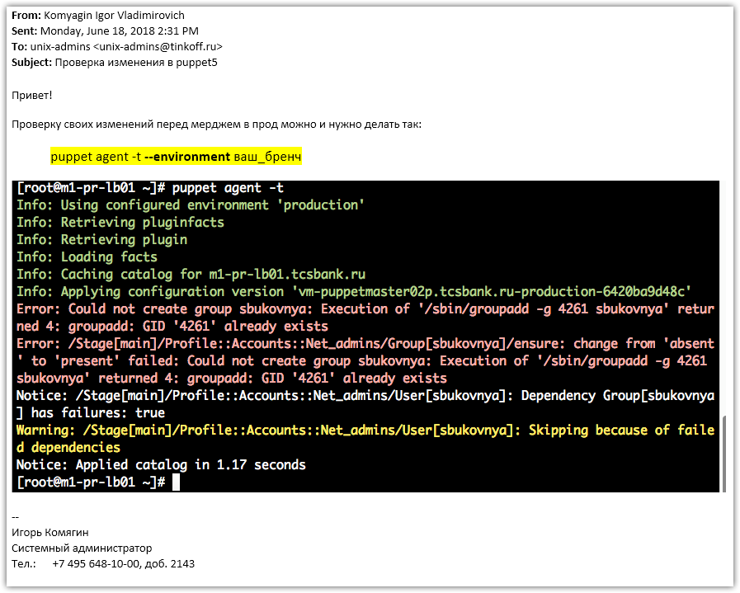

https://vm-gitlab01.tcsbank.ru/Puppet/control/merge_requests/641/diffs
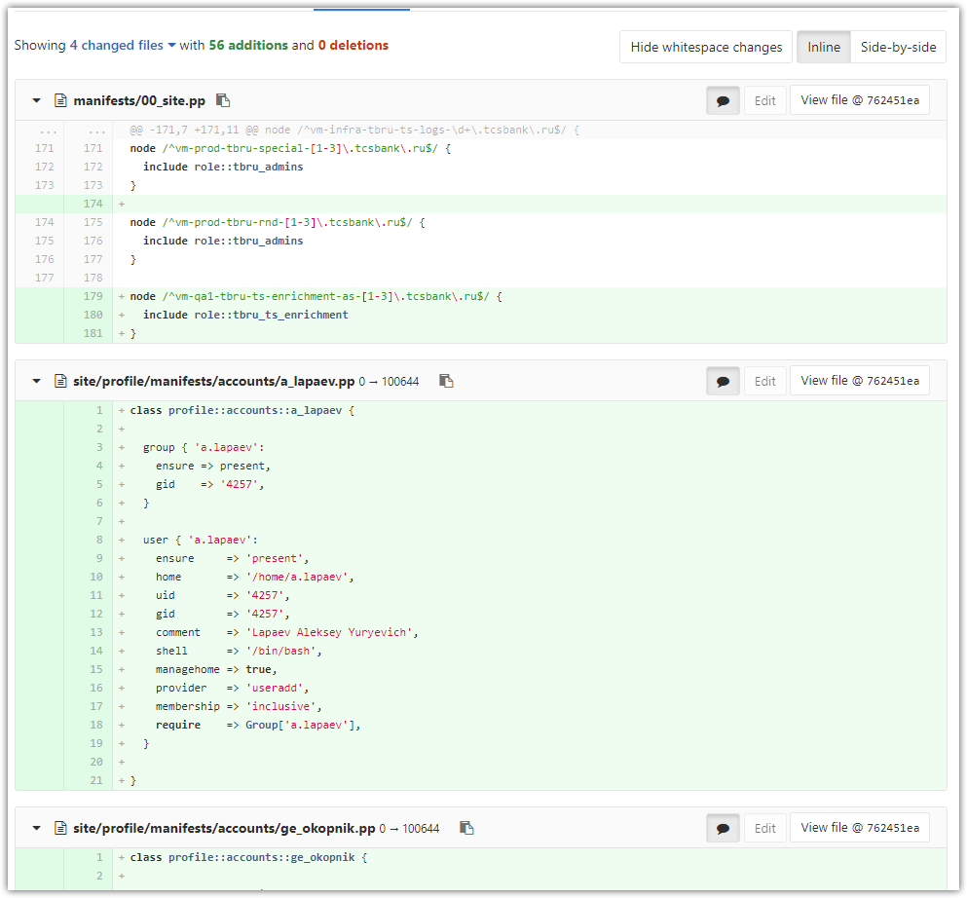

https://vm-gitlab01.tcsbank.ru/Puppet/control/merge_requests/649/diffs
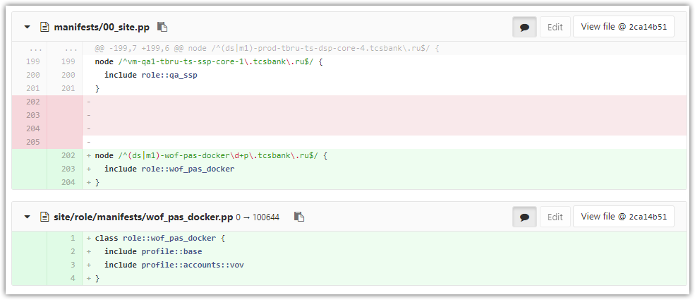

#
# Task was SD#1372211
# Prepare server to use. Give several users access to this server to administer it.
#
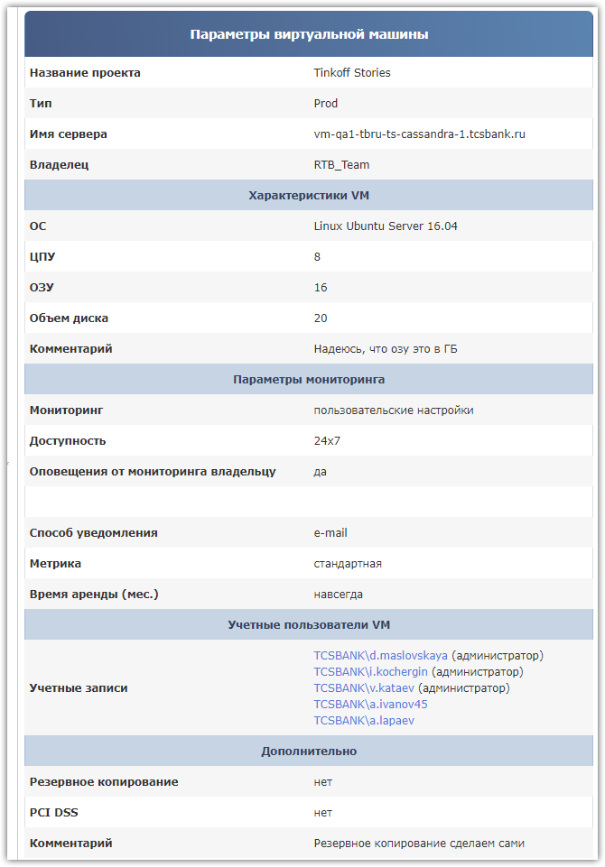

# Here is a list of exists accounts.
[s.belogrud@TCS4357]# ls -Alh site/profile/manifests/accounts/
total 383K
-rw-r--r-- 1 s.belogrud UsersGrp 599 июн 15 14:54 a_a_fedorov.pp
-rw-r--r-- 1 s.belogrud UsersGrp 594 июн 15 14:54 a_ivanov45.pp
-rw-r--r-- 1 s.belogrud UsersGrp 993 июн 15 14:54 a_lapaev.pp
-rw-r--r-- 1 s.belogrud UsersGrp 652 июн 15 14:54 a_lobachev.pp
...

# Required accounts already exists.
[s.belogrud@TCS4357]# ls -Alh site/profile/manifests/accounts/ | egrep -ie "maslov|kocher|kataev|ivanov|lapaev"
-rw-r--r-- 1 s.belogrud UsersGrp 594 июн 15 14:54 a_ivanov45.pp
-rw-r--r-- 1 s.belogrud UsersGrp 993 июн 15 14:54 a_lapaev.pp
-rw-r--r-- 1 s.belogrud UsersGrp 671 июн 15 14:54 d_maslovskaya.pp
-rw-r--r-- 1 s.belogrud UsersGrp 641 июн 15 14:54 i_kochergin.pp
-rw-r--r-- 1 s.belogrud UsersGrp 644 июн 15 14:54 v_kataev.pp

# Where they are used for.
[s.belogrud@TCS4357]# grep -rle "a_ivanov45" ./
./.git/index
./site/profile/manifests/accounts/a_ivanov45.pp
./site/role/manifests/qa_kafka.pp
./site/role/manifests/qa_ssp.pp
./site/role/manifests/tbru_admins.pp
./site/role/manifests/tbru_ts_dsp_as.pp
./site/role/manifests/tbru_ts_enrichment.pp
./site/role/manifests/tbru_ts_logs.pp
./site/role/manifests/ts_ssp.pp
[s.belogrud@TCS4357]# vim ./site/role/manifests/qa_kafka.pp
[s.belogrud@TCS4357]# grep -rle "qa_kafka" ./
./.git/index
./manifests/00_site.pp
./site/role/manifests/qa_kafka.pp
[s.belogrud@TCS4357]# vim -c "/qa_kafka" ./manifests/00_site.pp
[s.belogrud@TCS4357]# git branch 20180615_SD1372211
[s.belogrud@TCS4357]# git checkout 20180615_SD1372211
Switched to branch '20180615_SD1372211'
[s.belogrud@TCS4357]#

[s.belogrud@TCS4357]# vim -c "/qa_kafka" ./manifests/00_site.pp

[s.belogrud@TCS4357]# tail -n 3 manifests/00_site.pp
node /^vm-qa1-tbru-ts-cassandra-1\.tcsbank\.ru$/ {
include role::qa_kafka
}
[s.belogrud@TCS4357]#

[s.belogrud@TCS4357]# git status
On branch 20180615_SD1372211
Changes not staged for commit:
(use "git add <file>..." to update what will be committed)
(use "git checkout -- <file>..." to discard changes in working directory)

modified: manifests/00_site.pp

no changes added to commit (use "git add" and/or "git commit -a")
[s.belogrud@TCS4357]# git commit --author='Sergey Belogrud <s.belogrud@tinkoff.ru>' -m "SD#1372211. Needs to create users on server." manifests/00_site.pp
[20180615_SD1372211 c7be573] SD#1372211. Needs to create users on server.
Author: Sergey Belogrud <s.belogrud@tinkoff.ru>
1 file changed, 3 insertions(+)
[s.belogrud@TCS4357]#
[s.belogrud@TCS4357]# git branch
* 20180615_SD1372211
production
[s.belogrud@TCS4357]#

[s.belogrud@TCS4357]# git push origin 20180615_SD1372211
Counting objects: 4, done.
Delta compression using up to 8 threads.
Compressing objects: 100% (4/4), done.
Writing objects: 100% (4/4), 440 bytes | 0 bytes/s, done.
Total 4 (delta 3), reused 0 (delta 0)
remote:
remote: *** Checking puppet code style ***
remote:
remote: *** Checking puppet manifest syntax ***
remote:
remote: *** Checking puppet template(epp) syntax ***
remote:
remote: *** Checking ruby template(erb) syntax ***
remote:
remote: *** Checking ruby syntax ***
remote:
remote: *** Checking YAML syntax ***
remote:
remote: To create a merge request for 20180615_SD1372211, visit:
remote: https://vm-gitlab01.tcsbank.ru/Puppet/control/merge_requests/new?merge_request%5Bsource_branch%5D=20180615_SD1372211
remote:
To git@vm-gitlab01.tcsbank.ru:Puppet/control.git
* [new branch] 20180615_SD1372211 -> 20180615_SD1372211
[s.belogrud@TCS4357]#

# Then go to the link and merge.

[s.belogrud@TCS4357]# git checkout production
Switched to branch 'production'
Your branch is up-to-date with 'origin/production'.
[s.belogrud@TCS4357]# git branch -D 20180615_SD1372211
Deleted branch 20180615_SD1372211 (was c7be573).
[s.belogrud@TCS4357]# git pull
remote: Counting objects: 1, done.
remote: Total 1 (delta 0), reused 0 (delta 0)
Unpacking objects: 100% (1/1), done.
From vm-gitlab01.tcsbank.ru:Puppet/control
9739b01..6420ba9 production -> origin/production
Updating 9739b01..6420ba9
Fast-forward
manifests/00_site.pp | 3 +++
1 file changed, 3 insertions(+)
[s.belogrud@TCS4357]#

#
# How to fix puppet 5 bitch on two old Махнических servers.
#
# It was SD#1356172.

# Target servers have Ubuntu 16.

# Puppet 5 и как его готовить (по-русски)
# https://wiki.tcsbank.ru/pages/viewpage.action?pageId=268733855

# Here are articles, that help me.
# How to Install and Configure ‘Ansible’ Automation Tool for IT Management – Part 1
# https://www.tecmint.com/install-and-configure-ansible-automation-tool-in-linux/
#
# How to Use Ansible Playbooks to Automate Complex Tasks on Multiple Remote Servers – Part 2
# https://www.tecmint.com/use-ansible-playbooks-to-automate-complex-tasks-on-multiple-linux-servers/
#
# I just figured out how to use Ansible. This is my Hello World.
# https://gist.github.com/todgru/20064c02226091ae227746631da5622a

# I’ve installed ansible on my virtual box host.

[root@centos yum.repos.d]# yum install ansible
...
Install 1 Package (+11 Dependent packages)

Total size: 12 M
Total download size: 3.2 M
Installed size: 60 M
Is this ok [y/d/N]: y
Downloading packages:
(1/10): libtommath-0.42.0-6.el7.x86_64.rpm | 36 kB 00:00:00
(2/10): PyYAML-3.10-11.el7.x86_64.rpm | 153 kB 00:00:00
(3/10): libtomcrypt-1.17-26.el7.x86_64.rpm | 224 kB 00:00:00
(4/10): python-httplib2-0.9.2-1.el7.noarch.rpm | 115 kB 00:00:00
(5/10): python-jinja2-2.7.2-2.el7.noarch.rpm | 515 kB 00:00:00
(6/10): python-babel-0.9.6-8.el7.noarch.rpm | 1.4 MB 00:00:00
(7/10): python-markupsafe-0.11-10.el7.x86_64.rpm | 25 kB 00:00:00
(8/10): python-paramiko-2.1.1-4.el7.noarch.rpm | 268 kB 00:00:00
(9/10): python2-crypto-2.6.1-15.el7.x86_64.rpm | 477 kB 00:00:00
(10/10): python2-jmespath-0.9.0-3.el7.noarch.rpm | 39 kB 00:00:00
…
Installed:
ansible.noarch 0:2.5.3-1.el7

Dependency Installed:
PyYAML.x86_64 0:3.10-11.el7 libtomcrypt.x86_64 0:1.17-26.el7 libtommath.x86_64 0:0.42.0-6.el7 python-babel.noarch 0:0.9.6-8.el7 python-httplib2.noarch 0:0.9.2-1.el7
python-jinja2.noarch 0:2.7.2-2.el7 python-keyczar.noarch 0:0.71c-2.el7 python-markupsafe.x86_64 0:0.11-10.el7 python-paramiko.noarch 0:2.1.1-4.el7 python2-crypto.x86_64 0:2.6.1-15.el7
python2-jmespath.noarch 0:0.9.0-3.el7

Complete!
[root@centos yum.repos.d]#

# Here I’ve created key to use it for ansible to connect to server without password enter.
[support@centos 20180525-1714]$ ssh-keygen -t rsa -b 4096 -C "support"
Generating public/private rsa key pair.
Enter file in which to save the key (/home/support/.ssh/id_rsa):
Enter passphrase (empty for no passphrase):
Enter same passphrase again:
Your identification has been saved in /home/support/.ssh/id_rsa.
Your public key has been saved in /home/support/.ssh/id_rsa.pub.
The key fingerprint is:
89:c4:f0:96:8a:26:0a:6a:97:07:d2:64:5d:8e:ef:b1 support
The key's randomart image is:
+--[ RSA 4096]----+
| . . |
| .++. |
| o o*. |
| +. +.. . |
|o.oo. .oS |
|+o. o . o |
|o. o . E |
|. . . |
| |
+-----------------+
[support@centos 20180525-1714]$ ssh-copy-id root@vm-jasper6test-app01
The authenticity of host 'vm-jasper6test-app01 (10.218.17.128)' can't be established.
ECDSA key fingerprint is 4a:03:77:8c:b7:51:87:00:50:fd:7e:87:3c:69:d7:2c.
Are you sure you want to continue connecting (yes/no)? yes
/usr/bin/ssh-copy-id: INFO: attempting to log in with the new key(s), to filter out any that are already installed
/usr/bin/ssh-copy-id: INFO: 1 key(s) remain to be installed -- if you are prompted now it is to install the new keys
root@vm-jasper6test-app01's password:

Number of key(s) added: 1

Now try logging into the machine, with: "ssh 'root@vm-jasper6test-app01'"
and check to make sure that only the key(s) you wanted were added.

[support@centos 20180525-1714]$

# Test to login on target server via key authorisation.
[support@centos 20180525-1714]$ ssh root@vm-jasper6test-app01
Welcome to Ubuntu 16.04.4 LTS (GNU/Linux 4.4.0-97-generic x86_64)

* Documentation: https://help.ubuntu.com
* Management: https://landscape.canonical.com
* Support: https://ubuntu.com/advantage

3 packages can be updated.
0 updates are security updates.

Last login: Thu May 24 12:30:40 2018
root@vm-jasper6test-app01:~# logout
Connection to vm-jasper6test-app01 closed.
[support@centos 20180525-1714]$

# Here is a connectivity test.
[support@centos 20180525-1714]$ ansible -m ping all
vm-jasper6test-app01.tcsbank.ru | SUCCESS => {
"changed": false,
"ping": "pong"
}
[support@centos 20180525-1714]$

# Here I added host by host to apply ansible yuml scenario at servers.
[root@centos 20180525-1633]# tail -n 4 /etc/ansible/hosts

[all]
# vm-jasper6test-app01.tcsbank.ru ansible_user=root
vm-jasper6test-app02.tcsbank.ru ansible_user=root
[root@centos 20180525-1633]#

#
# Here is a file, that was taken from here https://vm-gitlab01/Ansible/playbooks/blob/master/puppet-agent.yaml and little modified.
#
[support@centos 20180525-1714]$ cat puppet-agent.yaml
---
- hosts: all

vars:
puppetserver: vm-puppetmaster02p.tcsbank.ru

tasks:
- name: Delete old puppet
package:
name: puppet
state: absent

- name: Purge directories of old puppet
file:
path: "{{ item }}"
state: absent
with_items:
- /var/lib/puppet
- /etc/puppet

- name: Delete old puppet repos (rpm)
shell: /usr/bin/find /etc/yum.repos.d/ -type f -name *puppet* -delete
when: ansible_os_family == "RedHat"

- name: Delete old puppet repos (deb)
shell: /usr/bin/find /etc/apt/source.list.d/ -type f -name *puppet* -delete
when: ansible_os_family == "Debian"
ignore_errors: yes

- name: Add Puppetlabs Repo v5 (rpm) for RHEL
yum_repository:
name: tcs-puppetlabs
description: Puppetlabs Repo (rpm)
baseurl: http://repo-linux.tcsbank.ru/puppetlabs/yum/puppet5/el/{{ ansible_distribution_major_version }}/$basearch
skip_if_unavailable: yes
repo_gpgcheck: no
gpgcheck: no
when: ansible_os_family == "RedHat"

- name: Add Puppetlabs Repo v5 (deb)
apt_repository:
filename: 'tcs-puppet5'
repo: "deb http://repo-linux.tcsbank.ru/puppetlabs/apt/ {{ ansible_lsb.codename|lower }} puppet5"
when: ansible_os_family == "Debian"
- name: Add Puppetlabs Repo key (deb)
apt_key:
url: "http://repo-linux/puppetlabs/apt/pubkey.gpg"
when: ansible_os_family == "Debian"

- name: Install new puppet
package:
name: puppet-agent
state: present

- name: Set puppet server in config
shell: "/opt/puppetlabs/bin/puppet config set server {{ puppetserver }}"

- name: Enable agent (for ubuntu)
shell: puppet agent --enable
ignore_errors: yes
when: ansible_distribution == "Ubuntu"

- name: First run puppet
puppet:
ignore_errors: yes

# - name: Sign node on master
# shell: /opt/puppetlabs/bin/puppet cert sign "{{ ansible_fqdn }}"
# delegate_to: "{{ puppetserver }}"
# ignore_errors: yes
#
# - name: Complete run puppet
# puppet:
[support@centos 20180525-1714]$

# Here is an example how looks run playbook.
# It have errors, but even so it do something usefull (removes puppet old 3 version). It’s better, than nothing.
[support@centos 20180525-1714]$ ansible-playbook puppet-agent.yaml

PLAY [all] **********************************************************************************************************************************************************************************************

TASK [Gathering Facts] **********************************************************************************************************************************************************************************
ok: [vm-jasper6test-app01.tcsbank.ru]

TASK [Delete old puppet] ********************************************************************************************************************************************************************************
ok: [vm-jasper6test-app01.tcsbank.ru]

TASK [Purge directories of old puppet] ******************************************************************************************************************************************************************
ok: [vm-jasper6test-app01.tcsbank.ru] => (item=/var/lib/puppet)
ok: [vm-jasper6test-app01.tcsbank.ru] => (item=/etc/puppet)

TASK [Delete old puppet repos (rpm)] ********************************************************************************************************************************************************************
skipping: [vm-jasper6test-app01.tcsbank.ru]

TASK [Delete old puppet repos (deb)] ********************************************************************************************************************************************************************
fatal: [vm-jasper6test-app01.tcsbank.ru]: FAILED! => {"changed": true, "cmd": "/usr/bin/find /etc/apt/source.list.d/ -type f -name *puppet* -delete", "delta": "0:00:00.002215", "end": "2018-05-25 17:57
:33.455510", "msg": "non-zero return code", "rc": 1, "start": "2018-05-25 17:57:33.453295", "stderr": "/usr/bin/find: ‘/etc/apt/source.list.d/’: No such file or directory", "stderr_lines": ["/usr/bin/f
ind: ‘/etc/apt/source.list.d/’: No such file or directory"], "stdout": "", "stdout_lines": []}
...ignoring

TASK [Add Puppetlabs Repo v5 (rpm) for RHEL] ************************************************************************************************************************************************************
skipping: [vm-jasper6test-app01.tcsbank.ru]

TASK [Add Puppetlabs Repo v5 (deb)] *********************************************************************************************************************************************************************
ok: [vm-jasper6test-app01.tcsbank.ru]

TASK [Add Puppetlabs Repo key (deb)] ********************************************************************************************************************************************************************
ok: [vm-jasper6test-app01.tcsbank.ru]

TASK [Install new puppet] *******************************************************************************************************************************************************************************
ok: [vm-jasper6test-app01.tcsbank.ru]

TASK [Set puppet server in config] **********************************************************************************************************************************************************************
changed: [vm-jasper6test-app01.tcsbank.ru]

TASK [Enable agent (for ubuntu)] ************************************************************************************************************************************************************************
fatal: [vm-jasper6test-app01.tcsbank.ru]: FAILED! => {"changed": true, "cmd": "puppet agent --enable", "delta": "0:00:00.001261", "end": "2018-05-25 17:57:37.963342", "msg": "non-zero return code", "rc
": 127, "start": "2018-05-25 17:57:37.962081", "stderr": "/bin/sh: 1: puppet: not found", "stderr_lines": ["/bin/sh: 1: puppet: not found"], "stdout": "", "stdout_lines": []}
...ignoring

TASK [First run puppet] *********************************************************************************************************************************************************************************
fatal: [vm-jasper6test-app01.tcsbank.ru]: FAILED! => {"changed": false, "disabled": false, "error": true, "msg": "puppet did not run", "rc": 1, "stderr": "Error: Could not request certificate: unexpect
ed attributes [\"pp_preshared_key\"] in \"/etc/puppetlabs/puppet/csr_attributes.yaml\"\n", "stderr_lines": ["Error: Could not request certificate: unexpected attributes [\"pp_preshared_key\"] in \"/etc
/puppetlabs/puppet/csr_attributes.yaml\""], "stdout": "Info: csr_attributes file loading from /etc/puppetlabs/puppet/csr_attributes.yaml\nExiting; failed to retrieve certificate and waitforcert is disa
bled\n", "stdout_lines": ["Info: csr_attributes file loading from /etc/puppetlabs/puppet/csr_attributes.yaml", "Exiting; failed to retrieve certificate and waitforcert is disabled"]}
...ignoring

PLAY RECAP **********************************************************************************************************************************************************************************************
vm-jasper6test-app01.tcsbank.ru : ok=10 changed=3 unreachable=0 failed=0

[support@centos 20180525-1714]$

#
# On next steps I’ve manually install new version of puppet on the server (version 5 instead old 3).
#
# This is not necessary to do, I think.
root@vm-jasper6test-app02:~# apt-get update
Hit:1 http://repo-linux.tcsbank.ru/ubuntu xenial InRelease
Hit:2 http://repo-linux.tcsbank.ru/ubuntu xenial-updates InRelease
Hit:3 http://repo-linux.tcsbank.ru/ubuntu xenial-backports InRelease
Hit:4 http://repo-linux.tcsbank.ru/ubuntu xenial-security InRelease
Reading package lists... Done
root@vm-jasper6test-app02:~#

# Here we go!
root@vm-jasper6test-app02:~# apt-get install puppet-agent
Reading package lists... Done
Building dependency tree
Reading state information... Done
E: Unable to locate package puppet-agent
root@vm-jasper6test-app02:~# passwd
Enter new UNIX password:
Retype new UNIX password:
passwd: password updated successfully
root@vm-jasper6test-app02:~# apt-get install puppet-agent
Reading package lists... Done
Building dependency tree
Reading state information... Done
The following packages were automatically installed and are no longer required:
augeas-lenses fonts-lato hiera javascript-common libaugeas0 libjs-jquery libruby2.3 libyaml-0-2 rake ruby ruby-augeas ruby-deep-merge ruby-did-you-mean ruby-json ruby-minitest ruby-net-telnet
ruby-nokogiri ruby-power-assert ruby-rgen ruby-safe-yaml ruby-selinux ruby-shadow ruby-test-unit ruby2.3 rubygems-integration virt-what
Use 'sudo apt autoremove' to remove them.
The following packages will be REMOVED:
facter puppet-common
The following NEW packages will be installed:
puppet-agent
0 upgraded, 1 newly installed, 2 to remove and 3 not upgraded.
Need to get 17.2 MB of archives.
After this operation, 90.3 MB of additional disk space will be used.
Do you want to continue? [Y/n] Y
WARNING: The following packages cannot be authenticated!
puppet-agent
Install these packages without verification? [y/N] y
Get:1 http://repo-linux.tcsbank.ru/puppetlabs/apt xenial/puppet5 amd64 puppet-agent amd64 5.5.1-1xenial [17.2 MB]
Fetched 17.2 MB in 0s (28.0 MB/s)
(Reading database ... 65941 files and directories currently installed.)
Removing puppet-common (3.8.5-2ubuntu0.1) ...
Removing facter (2.4.6-1) ...
Processing triggers for man-db (2.7.5-1) ...
Selecting previously unselected package puppet-agent.
(Reading database ... 64496 files and directories currently installed.)
Preparing to unpack .../puppet-agent_5.5.1-1xenial_amd64.deb ...
Unpacking puppet-agent (5.5.1-1xenial) ...
Processing triggers for libc-bin (2.23-0ubuntu10) ...
Setting up puppet-agent (5.5.1-1xenial) ...
....

# Now puppet is version 5.
root@vm-jasper6test-app01:~# puppet -V
5.5.1
root@vm-jasper6test-app01:~#

# Here I’ve written puppet 5 server.
root@vm-jasper6test-app02:~# cat > /etc/puppetlabs/puppet/puppet.conf
[main]
server = vm-puppetmaster02p.tcsbank.ru
root@vm-jasper6test-app02:~#

# Path is broken - need correction PATH variable.
root@vm-jasper6test-app02:~# puppet agent -t
-bash: /usr/bin/puppet: No such file or directory
root@vm-jasper6test-app02:~#
#
# Relogin will fix this difficulties.
# root@vm-jasper6test-app01:~# source /etc/profile
#
root@vm-jasper6test-app02:~# logout
bsv@vm-jasper6test-app02:~$ sudo -i
[sudo] password for bsv:
root@vm-jasper6test-app02:~#

# At this step I’ve generated key and publish it on puppet server.
root@vm-jasper6test-app02:~# puppet agent -t
Info: Creating a new SSL key for vm-jasper6test-app02.tcsbank.ru
Info: Caching certificate for ca
Info: csr_attributes file loading from /etc/puppetlabs/puppet/csr_attributes.yaml
Info: Creating a new SSL certificate request for vm-jasper6test-app02.tcsbank.ru
Info: Certificate Request fingerprint (SHA256): 08:35:57:8A:33:7A:41:C9:3B:62:FF:AC:A7:95:B2:FE:DF:D2:5A:F0:91:28:30:21:EF:49:E8:1A:57:F2:D7:63
Info: Caching certificate for ca
Exiting; no certificate found and waitforcert is disabled
root@vm-jasper6test-app02:~#

#
# It’s need to go to puppet 5 server and sign certificate manually.
#
[root@vm-puppetmaster02p puppetlabs]# puppet cert list | grep -e "vm-jasper6test-app01"
"vm-jasper6test-app01.tcsbank.ru" (SHA256) 1A:66:E8:8A:93:11:E0:10:23:60:C8:B0:B3:B6:F8:16:F9:48:8F:9A:DF:C9:52:DC:17:60:AC:00:E0:95:B8:12
[root@vm-puppetmaster02p puppetlabs]# puppet cert sign "vm-jasper6test-app01.tcsbank.ru"
Signing Certificate Request for:
"vm-jasper6test-app01.tcsbank.ru" (SHA256) 1A:66:E8:8A:93:11:E0:10:23:60:C8:B0:B3:B6:F8:16:F9:48:8F:9A:DF:C9:52:DC:17:60:AC:00:E0:95:B8:12
Notice: Signed certificate request for vm-jasper6test-app01.tcsbank.ru
Notice: Removing file Puppet::SSL::CertificateRequest vm-jasper6test-app01.tcsbank.ru at '/etc/puppetlabs/puppet/ssl/ca/requests/vm-jasper6test-app01.tcsbank.ru.pem'
[root@vm-puppetmaster02p puppetlabs]#

# At this point all default manifestes will be applyed.
root@vm-jasper6test-app02:~# puppet agent -t

#
# Where is new puppet server name is.
#
root@ds-saascrm-prod-app-2:~# tail -n 2 /etc/puppetlabs/puppet/puppet.conf
[agent]
server = vm-puppetmaster02p.tcsbank.ru
root@ds-saascrm-prod-app-2:~#

# Something for ubuntu.
root@ds-saascrm-prod-app-2:~# cat $(puppet agent --configprint classfile)
settings
default
role::default
profile::base
profile::base::ntp
ntp
ntp::install
ntp::config
ntp::service
profile::base::packages
profile::base::sysstat_config
profile::base::firewall
firewall::params
firewall
firewall::linux
firewall::linux::debian
profile::accounts::admins
profile::base::nrpe
tcs_nrpe::params
tcs_nrpe
tcs_nrpe::install
tcs_nrpe::config
tcs_nrpe::service
profile::base::puppet_agent
profile::base::sysctl
sysctl::params
sysctl::base
root@ds-saascrm-prod-app-2:~#

root@ds-saascrm-prod-app-2:~# cat /etc/os-release
NAME="Ubuntu"
VERSION="16.04.4 LTS (Xenial Xerus)"
ID=ubuntu
ID_LIKE=debian
PRETTY_NAME="Ubuntu 16.04.4 LTS"
...

# 20180222
# How to make change into one tcs_nrpe manifest’s file
#

# This way I see - this server is under bitch puppet 5 version.
[root@ds-mvno-sorm-ftp01 nrpe.d]# grep "^server" /etc/puppetlabs/puppet/puppet.conf
server = vm-puppetmaster02p.tcsbank.ru
[root@ds-mvno-sorm-ftp01 nrpe.d]#

# This need one time.
[s.belogrud@TCS4357]# git clone git@vm-gitlab01.tcsbank.ru:Puppet/tcs_nrpe.git

[s.belogrud@TCS4357]# git branch 20180222_SD#994955

[s.belogrud@TCS4357]# git branch
20180222_SD#994955
* master
[s.belogrud@TCS4357]# git checkout 20180222_SD#994955
Switched to branch '20180222_SD#994955'
[s.belogrud@TCS4357]#

# Go to here.
[s.belogrud@TCS4357]# pwd
/home/mobaxterm/work/puppet/tcs_nrpe
[s.belogrud@TCS4357]#

[s.belogrud@TCS4357]# vim files/nrpe.d/RedHat/check_disks.cfg

[s.belogrud@TCS4357]# git status
On branch 20180222_SD#994955
Changes not staged for commit:
(use "git add <file>..." to update what will be committed)
(use "git checkout -- <file>..." to discard changes in working directory)

modified: files/nrpe.d/RedHat/check_disks.cfg

no changes added to commit (use "git add" and/or "git commit -a")
[s.belogrud@TCS4357]#

[s.belogrud@TCS4357]# git commit --author='Sergey Belogrud <s.belogrud@tinkoff.ru>' -m "SD#994955. Was added one disk check." files/nrpe.d/RedHat/check_disks.cfg
[20180222_SD#994955 7cec83a] SD#994955. Was added one disk check.
Author: Sergey Belogrud <s.belogrud@tinkoff.ru>
1 file changed, 2 insertions(+), 1 deletion(-)
[s.belogrud@TCS4357]# git branch
* 20180222_SD#994955
master
[s.belogrud@TCS4357]#

[s.belogrud@TCS4357]# git push origin 20180222_SD#994955
Counting objects: 6, done.
Delta compression using up to 8 threads.
Compressing objects: 100% (6/6), done.
Writing objects: 100% (6/6), 585 bytes | 0 bytes/s, done.
Total 6 (delta 3), reused 0 (delta 0)
remote:
remote: To create a merge request for 20180222_SD#994955, visit:
remote: https://vm-gitlab01.tcsbank.ru/Puppet/tcs_nrpe/merge_requests/new?merge_request%5Bsource_branch%5D=20180222_SD%23994955
remote:
To git@vm-gitlab01.tcsbank.ru:Puppet/tcs_nrpe.git
* [new branch] 20180222_SD#994955 -> 20180222_SD#994955
[s.belogrud@TCS4357]#

#
# Go to here: https://gitlab.tcsbank.ru/Puppet/tcs_nrpe
# Merge my branch into master.
#

# To receive new changes into puppet we need run deployment process.
# This command ask puppet to go to its sources and update from it.
# The keys “-pv” must exist. Instead there will be nothing.
[root@vm-puppetmaster02p RedHat]# /opt/puppetlabs/puppet/bin/r10k deploy environment -pv

# It’s for information.
# This file contain sources from where puppet get new its shit to deploy it on servers.
[root@vm-puppetmaster02p RedHat]# vim -R /etc/puppetlabs/code/environments/production/Puppetfile

#
# Go to target server and run
# puppet agent -t
# to test results.
#

[s.belogrud@TCS4357]# git branch -D 20180222_SD#994955
Deleted branch 20180222_SD#994955 (was 7cec83a).
[s.belogrud@TCS4357]#

[s.belogrud@TCS4357]# git pull
remote: Counting objects: 1, done.
remote: Total 1 (delta 0), reused 1 (delta 0)
Unpacking objects: 100% (1/1), done.
From vm-gitlab01.tcsbank.ru:Puppet/tcs_nrpe
857b431..98325f9 master -> origin/master
Updating 857b431..98325f9
Fast-forward
files/nrpe.d/RedHat/check_disks.cfg | 3 ++-
1 file changed, 2 insertions(+), 1 deletion(-)
[s.belogrud@TCS4357]#

[s.belogrud@TCS4357]# git --no-pager log -n 2 -p
commit 98325f9b210bd6d9dfba53aff8bcdd09646b346b
Merge: 857b431 7cec83a
Author: Белогруд Сергей Владимирович <s.belogrud@tinkoff.ru>
Date: Thu Feb 22 17:41:05 2018 +0300

Merge branch '20180222_SD#994955' into 'master'

SD#994955. Was added one disk check.

See merge request !3

commit 7cec83aedcce382a978f9bcbe1dfd9290dc27191
Author: Sergey Belogrud <s.belogrud@tinkoff.ru>
Date: Thu Feb 22 17:38:18 2018 +0300

SD#994955. Was added one disk check.

diff --git a/files/nrpe.d/RedHat/check_disks.cfg b/files/nrpe.d/RedHat/check_disks.cfg
index c7c6712..597c3fb 100644
--- a/files/nrpe.d/RedHat/check_disks.cfg
+++ b/files/nrpe.d/RedHat/check_disks.cfg
@@ -6,4 +6,5 @@ command[check_usr_fs]=/usr/lib64/nagios/plugins/check_disk -W 20% -K 10% -w 20%
command[check_data1_fs]=/usr/lib64/nagios/plugins/check_disk -W 10% -K 5% -w 10% -c 5% -p /data1
command[check_data2_fs]=/usr/lib64/nagios/plugins/check_disk -W 10% -K 5% -w 10% -c 5% -p /data2
command[check_duet_fs]=/usr/lib64/nagios/plugins/check_disk -W 10% -K 5% -w 10% -c 5% -p /duet
-command[check_disk]=/usr/lib64/nagios/plugins/check_disk -w $ARG1$ -c $ARG2$ -W $ARG1$ -K $ARG2$ -p $ARG3$
\ No newline at end of file
+command[check_disk]=/usr/lib64/nagios/plugins/check_disk -w $ARG1$ -c $ARG2$ -W $ARG1$ -K $ARG2$ -p $ARG3$
+command[check_disk_size]=/usr/lib64/nagios/plugins/check_disk -w $ARG1$ -c $ARG2$ -p $ARG3$
[s.belogrud@TCS4357]#

#
# 20180827
# On Ubuntu 14.04.5 LTS

root@vm-secstorage01:~# puppet agent -t -v
Warning: Downgrading to PSON for future requests
Error: Could not request certificate: Error 400 on SERVER: The environment must be purely alphanumeric, not 'puppet-ca'
Exiting; failed to retrieve certificate and waitforcert is disabled
root@vm-secstorage01:~#

root@vm-secstorage01:~# telnet vm-puppetmaster02p.tcsbank.ru 8140
Trying 10.216.40.228...
Connected to vm-puppetmaster02p.tcsbank.ru.
Escape character is '^]'.
^CConnection closed by foreign host.
You have new mail in /var/mail/root
root@vm-secstorage01:~#

root@vm-secstorage01:~# puppet agent -V
5.3.3
You have new mail in /var/mail/root
root@vm-secstorage01:~#

root@vm-secstorage01:~# puppet agent --test --server=vm-puppetmaster02p.tcsbank.ru
Info: csr_attributes file loading from /etc/puppetlabs/puppet/csr_attributes.yaml
Info: Creating a new SSL certificate request for vm-secstorage01.tcsbank.ru
Info: Certificate Request fingerprint (SHA256): 87:11:7D:D8:C8:23:4C:36:65:B9:DE:83:29:A6:A1:1E:74:84:89:0E:CF:91:A3:A3:40:C4:38:7C:93:AD:49:8A
Info: Caching certificate for vm-secstorage01.tcsbank.ru
Info: Caching certificate for vm-secstorage01.tcsbank.ru
Info: Using configured environment 'production'
Info: Retrieving pluginfacts
Info: Retrieving plugin
Info: Loading facts
Info: Caching catalog for vm-secstorage01.tcsbank.ru
Info: Applying configuration version 'vm-puppetmaster02p.tcsbank.ru-production-be8b343c0d6'
Notice: /Stage[main]/Tcs_nrpe::Config/File[/etc/nagios/nrpe.d/check_load.cfg]/content:
--- /etc/nagios/nrpe.d/check_load.cfg 2018-07-03 16:47:13.491879866 +0300
+++ /tmp/puppet-file20180827-28056-chmyp7 2018-08-27 18:27:42.678316716 +0300
@@ -1 +1 @@
-command[check_load]=/usr/lib/nagios/plugins/check_load -w 5,3,1 -c 11,9,7
+command[check_load]=/usr/lib/nagios/plugins/check_load -w 6,4,2 -c 12,10,8

Notice: /Stage[main]/Tcs_nrpe::Config/File[/etc/nagios/nrpe.d/check_load.cfg]/content: content changed '{md5}75734ac1b90c7af84582f982014c1d03' to '{md5}8679a3ee0a8dd35c6844964c5d9d14bb'
Info: Class[Tcs_nrpe::Config]: Scheduling refresh of Class[Tcs_nrpe::Service]
Info: Class[Tcs_nrpe::Service]: Scheduling refresh of Service[nagios-nrpe-server]
Notice: /Stage[main]/Tcs_nrpe::Service/Service[nagios-nrpe-server]: Triggered 'refresh' from 1 event
Notice: /Stage[main]/Profile::Accounts::L_korytkina/Group[l.korytkina]/ensure: created
Notice: /Stage[main]/Profile::Accounts::L_korytkina/User[l.korytkina]/ensure: created
Notice: /Stage[main]/Profile::Accounts::S_rychikhin/Group[s.rychikhin]/ensure: created
Notice: /Stage[main]/Profile::Accounts::S_rychikhin/User[s.rychikhin]/ensure: created
Notice: /Stage[main]/Profile::Accounts::A_s_khokhlov/Group[a.s.khokhlov]/ensure: created
Notice: /Stage[main]/Profile::Accounts::A_s_khokhlov/User[a.s.khokhlov]/ensure: created
Notice: /Stage[main]/Profile::Accounts::A_bikkinyaeva/Group[a.bikkinyaeva]/ensure: created
Notice: /Stage[main]/Profile::Accounts::A_bikkinyaeva/User[a.bikkinyaeva]/ensure: created
Notice: /Stage[main]/Profile::Accounts::S_v_pavlov_no_sudo/Group[s.v.pavlov]/ensure: created
Notice: /Stage[main]/Profile::Accounts::S_v_pavlov_no_sudo/User[s.v.pavlov]/ensure: created
Notice: Applied catalog in 2.75 seconds
You have new mail in /var/mail/root
root@vm-secstorage01:~#

#
# To resolve issue, needs to add two last lines into the file.
root@vm-secstorage01:~# cat /etc/puppetlabs/puppet/puppet.conf
# This file can be used to override the default puppet settings.
# See the following links for more details on what settings are available:
# - https://docs.puppetlabs.com/puppet/latest/reference/config_important_settings.html
# - https://docs.puppetlabs.com/puppet/latest/reference/config_about_settings.html
# - https://docs.puppetlabs.com/puppet/latest/reference/config_file_main.html
# - https://docs.puppetlabs.com/puppet/latest/reference/configuration.html
[agent]
server = vm-puppetmaster02p.tcsbank.ru

root@vm-secstorage01:~#

root@vm-secstorage01:~# puppet agent -t
Info: Using configured environment 'production'
Info: Retrieving pluginfacts
Info: Retrieving plugin
Info: Loading facts
Info: Caching catalog for vm-secstorage01.tcsbank.ru
Info: Applying configuration version 'vm-puppetmaster02p.tcsbank.ru-production-be8b343c0d6'
Notice: Applied catalog in 1.28 seconds
root@vm-secstorage01:~#

#
# 20190124
# How to lock account with puppet.
#

# To lock account can be used follow methods.
# 1. Place special character into password hash. For example “!” or “*”. Here is more info https://serverfault.com/questions/588936/how-to-disable-users-password-via-puppet-securely
# 2. Make account expired with puppet attribute “expire”. https://puppet.com/docs/puppet/5.5/types/user.html
# 3. If exists key - fill in it with blank.
#

[s.belogrud@TCS4357]# vim site/profile/manifests/accounts/einsapov.pp
[s.belogrud@TCS4357]# cat site/profile/manifests/accounts/einsapov.pp
class profile::accounts::einsapov inherits profile::accounts::params {

group { 'e.insapov':
ensure => present,
gid => '680',
}

user { 'e.insapov':
ensure => 'present',
home => '/home/e.insapov',
uid => '680',
gid => '680',
groups => $admningroup,
comment => 'Insapov Eldar Mavzirovich',
shell => '/bin/bash',
password => '!!$6$fJ5hPuprovT7crz6$97CxHw/VTIXZHSBROhxKqRtuxTvIIA1hiAGHDlhQTj//pzaavw89WoUxYYGtGdyEDl2oy1KH0wyhAgj60nXM.0',
managehome => true,
provider => 'useradd',
membership => 'inclusive',
require => Group['e.insapov'],
}
}
[s.belogrud@TCS4357]#

[root@ds-vcs04t ~]# awk '/e.insapov/{print}' /etc/{passwd,shadow}
e.insapov:x:680:680:Insapov Eldar Mavzirovich:/home/e.insapov:/bin/bash
e.insapov:!!$6$fJ5hPuprovT7crz6$97CxHw/VTIXZHSBROhxKqRtuxTvIIA1hiAGHDlhQTj//pzaavw89WoUxYYGtGdyEDl2oy1KH0wyhAgj60nXM.0:17920:0:99999:7:::
[root@ds-vcs04t ~]#

[root@ds-vcs04t ~]# passwd -S e.insapov
e.insapov LK 2019-01-24 0 99999 7 -1 (Password locked.)
[root@ds-vcs04t ~]#

#
# 20190411
# One plain mistake and followed error.
# In this case I’ve ran puppet under non root user - bsv
# It’s need to be run under root user.
#
[bsv@ds-postgresql86p ~]$ puppet agent -t
Warning: Downgrading to PSON for future requests
Error: Could not request certificate: Error 400 on SERVER: The environment must be purely alphanumeric, not 'puppet-ca'
Exiting; failed to retrieve certificate and waitforcert is disabled
[bsv@ds-postgresql86p ~]$

# https://serverfault.com/questions/700181/error-400-on-server-the-environment-must-be-purely-alphanumeric-not-puppet-ca/841046
#

#
# 20200323
# How to add user into admin group to give him sudo rights.
# SD#3840595
#

#
# I’ve added construction “concat…”
# I took example from site/profile/manifests/accounts/afsadmin.pp.
#
[s.belogrud@TCS4357]# cat site/profile/manifests/accounts/bettersearch.pp
...
user {'bettersearch':
...
groups => concat(['docker'], $admningroup),
...
require => Group['bettersearch', 'docker'],
}

}
[s.belogrud@TCS4357]#

root@m1-prod-bettersearch-smg-py-1:~# id bettersearch
uid=4971(bettersearch) gid=4971(bettersearch) groups=999(docker),4971(bettersearch)
root@m1-prod-bettersearch-smg-py-1:~# puppet agent -t --environment 20200323_SD3840595
Info: Using configured environment '20200323_SD3840595'
Info: Retrieving pluginfacts
Info: Retrieving plugin
Info: Loading facts
Info: Caching catalog for m1-prod-bettersearch-smg-py-1.tcsbank.ru
Info: Applying configuration version 'vm-puppetmaster02p.tcsbank.ru-20200323_SD3840595-137d441b18f'
Notice: /Stage[main]/Profile::Accounts::Bettersearch/User[bettersearch]/groups: groups changed docker to ['docker', 'sudo']
Notice: Applied catalog in 2.96 seconds
root@m1-prod-bettersearch-smg-py-1:~# id bettersearch
uid=4971(bettersearch) gid=4971(bettersearch) groups=27(sudo),999(netdata),4971(bettersearch)
root@m1-prod-bettersearch-smg-py-1:~# sudo -l -U bettersearch
Matching Defaults entries for bettersearch on m1-prod-bettersearch-smg-py-1.tcsbank.ru:
env_reset, mail_badpass, secure_path=/usr/local/sbin\:/usr/local/bin\:/usr/sbin\:/usr/bin\:/sbin\:/bin\:/snap/bin

User bettersearch may run the following commands on m1-prod-bettersearch-smg-py-1.tcsbank.ru:
(ALL : ALL) ALL
root@m1-prod-bettersearch-smg-py-1:~#

